U21CS501
Web Technology

Assignment – 1

Submission By – Subigya Budhathoki
Roll No. – 24CS291
Year – III CSE ‘A’
Scenario: A newly established educational institution plans to launch its official website. Before developing the website, the management wants to understand the fundamental concepts of the World Wide Web.
Task: Create a simple HTML webpage explaining the following concepts with suitable illustrations or diagrams:
• Internet Overview
• Fundamental Computer Network Concepts
• URL and its Structure
• Domain Name
• Web Browsers and Web Servers
• Working Principle of a Website
• Difference between Client-side and Server-side Scripting
ANSWER
- HTML source code

<!DOCTYPE html>
<html lang="en">
<head>
<meta charset="UTF-8">
<meta name="viewport" content="width=device-width, initial-scale=1.0">
<title>Fundamentals of the World Wide Web</title>

<style>
/* Basic page styling */
body {
font-family: Arial, sans-serif;
margin: 0;
background-color: #f4f7fb;
color: #222;
line-height: 1.6;
}

header {
background-color: #1d4ed8;
color: white;
text-align: center;
padding: 25px;
}

section {
background-color: white;
width: 85%;
margin: 20px auto;
padding: 20px;
border-radius: 10px;
box-shadow: 0 2px 8px rgba(0,0,0,0.1);
}

h2 {
color: #1d4ed8;
border-bottom: 2px solid #1d4ed8;
padding-bottom: 5px;
}

/* Diagram boxes */
.diagram {
display: flex;
justify-content: center;
align-items: center;
gap: 15px;
flex-wrap: wrap;
margin: 20px 0;
}

.box {
background-color: #dbeafe;
border: 2px solid #1d4ed8;
padding: 15px;
border-radius: 8px;
text-align: center;
font-weight: bold;
}

.arrow {
font-size: 25px;
color: #1d4ed8;
}

.url {
background-color: #eef2ff;
padding: 15px;
border-left: 5px solid #1d4ed8;
font-family: monospace;
word-break: break-all;
}

footer {
text-align: center;
background-color: #1e293b;
color: white;
padding: 15px;
margin-top: 30px;
}
</style>
</head>

<body>

<header>
<h1>Fundamentals of the World Wide Web</h1>
<p>Understanding how websites and the Internet work</p>
</header>

<!-- 1. Internet Overview -->
<section>
<h2>1. Internet Overview</h2>
<p>
The Internet is a worldwide network of interconnected computers
and devices. It allows users to communicate, share information,
access websites, send emails and use online services.
</p>

<div class="diagram">
<div class="box">Computer</div>
<div class="arrow">↔</div>
<div class="box">Internet</div>
<div class="arrow">↔</div>
<div class="box">Web Server</div>
</div>
</section>

<!-- 2. Network Concepts -->
<section>
<h2>2. Fundamental Computer Network Concepts</h2>
<p>
A computer network connects two or more devices so that they can
communicate and share resources.
</p>

<ul>
<li><b>IP Address:</b> Identifies a device on a network.</li>
<li><b>Protocol:</b> A set of rules used for communication.</li>
<li><b>TCP/IP:</b> A collection of protocols used for Internet communication.</li>
<li><b>HTTP/HTTPS:</b> Protocols used for communication between browsers and web servers.</li>
</ul>

<div class="diagram">
<div class="box">Client</div>
<div class="arrow">→</div>
<div class="box">Network</div>
<div class="arrow">→</div>
<div class="box">Server</div>
</div>
</section>

<!-- 3. URL -->
<section>
<h2>3. URL and its Structure</h2>

<p>
A URL (Uniform Resource Locator) is the address used to locate
a resource on the Internet.
</p>

<div class="url">
https://www.example.com/products/index.html
</div>

<ul>
<li><b>https:</b> Protocol</li>
<li><b>www:</b> Host/Subdomain</li>
<li><b>example.com:</b> Domain name</li>
<li><b>/products/index.html:</b> Path to the resource</li>
</ul>
</section>

<!-- 4. Domain Name -->
<section>
<h2>4. Domain Name</h2>

<p>
A domain name is a human-readable name used to identify a website.
It is easier to remember than an IP address.
</p>

<div class="diagram">
<div class="box">www</div>
<div class="arrow">.</div>
<div class="box">example</div>
<div class="arrow">.</div>
<div class="box">com</div>
</div>

<p>
Example: <b>www.example.com</b>
</p>
</section>

<!-- 5. Browser and Server -->
<section>
<h2>5. Web Browsers and Web Servers</h2>

<p>
A <b>web browser</b> is software used to access and display
websites. Examples include Google Chrome, Mozilla Firefox and
Microsoft Edge.
</p>

<p>
A <b>web server</b> is a computer or software system that stores
website files and sends them to clients when requested.
</p>

<div class="diagram">
<div class="box">Web Browser<br>(Client)</div>
<div class="arrow">⇄</div>
<div class="box">Web Server</div>
</div>
</section>

<!-- 6. Working Principle -->
<section>
<h2>6. Working Principle of a Website</h2>

<p>
When a user enters a website address, the browser sends a request
to the web server. The server processes the request and sends the
required web resources back to the browser. The browser then
displays the webpage.
</p>

<div class="diagram">
<div class="box">1. User enters URL</div>
<div class="arrow">→</div>
<div class="box">2. Browser sends request</div>
<div class="arrow">→</div>
<div class="box">3. Server responds</div>
<div class="arrow">→</div>
<div class="box">4. Page displayed</div>
</div>
</section>

<!-- 7. Client vs Server -->
<section>
<h2>7. Client-side vs Server-side Scripting</h2>

<div class="diagram">
<div class="box">
Client-side<br><br>
Runs in the user's browser<br>
Example: JavaScript
</div>

<div class="box">
Server-side<br><br>
Runs on the web server<br>
Example: PHP, Python
</div>
</div>

<ul>
<li>
<b>Client-side scripting:</b> Code is executed in the user's
browser and is mainly used for interactive user interfaces.
</li>
<li>
<b>Server-side scripting:</b> Code is executed on the server
and is used for processing data, authentication and database
operations.
</li>
</ul>
</section>

<footer>
<p>Web Technology – Assignment I | Q1</p>
</footer>

</body>
</html>

- Explanation
The webpage is developed using HTML5 and CSS3. HTML provides the structure and content of the webpage, while CSS is used for formatting, colors, spacing, borders and diagrams. The webpage explains the Internet, computer networks, URL structure, domain names, browsers, web servers, website working, and client-side/server-side scripting.

- Output
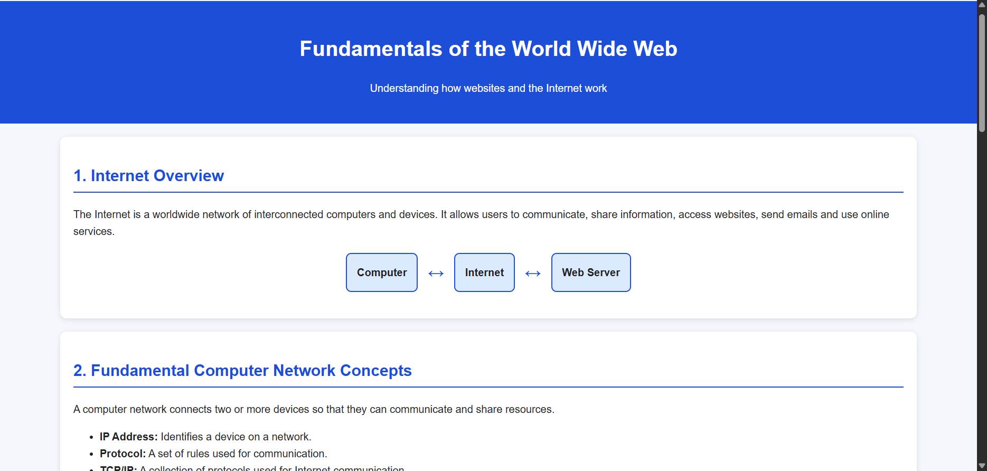
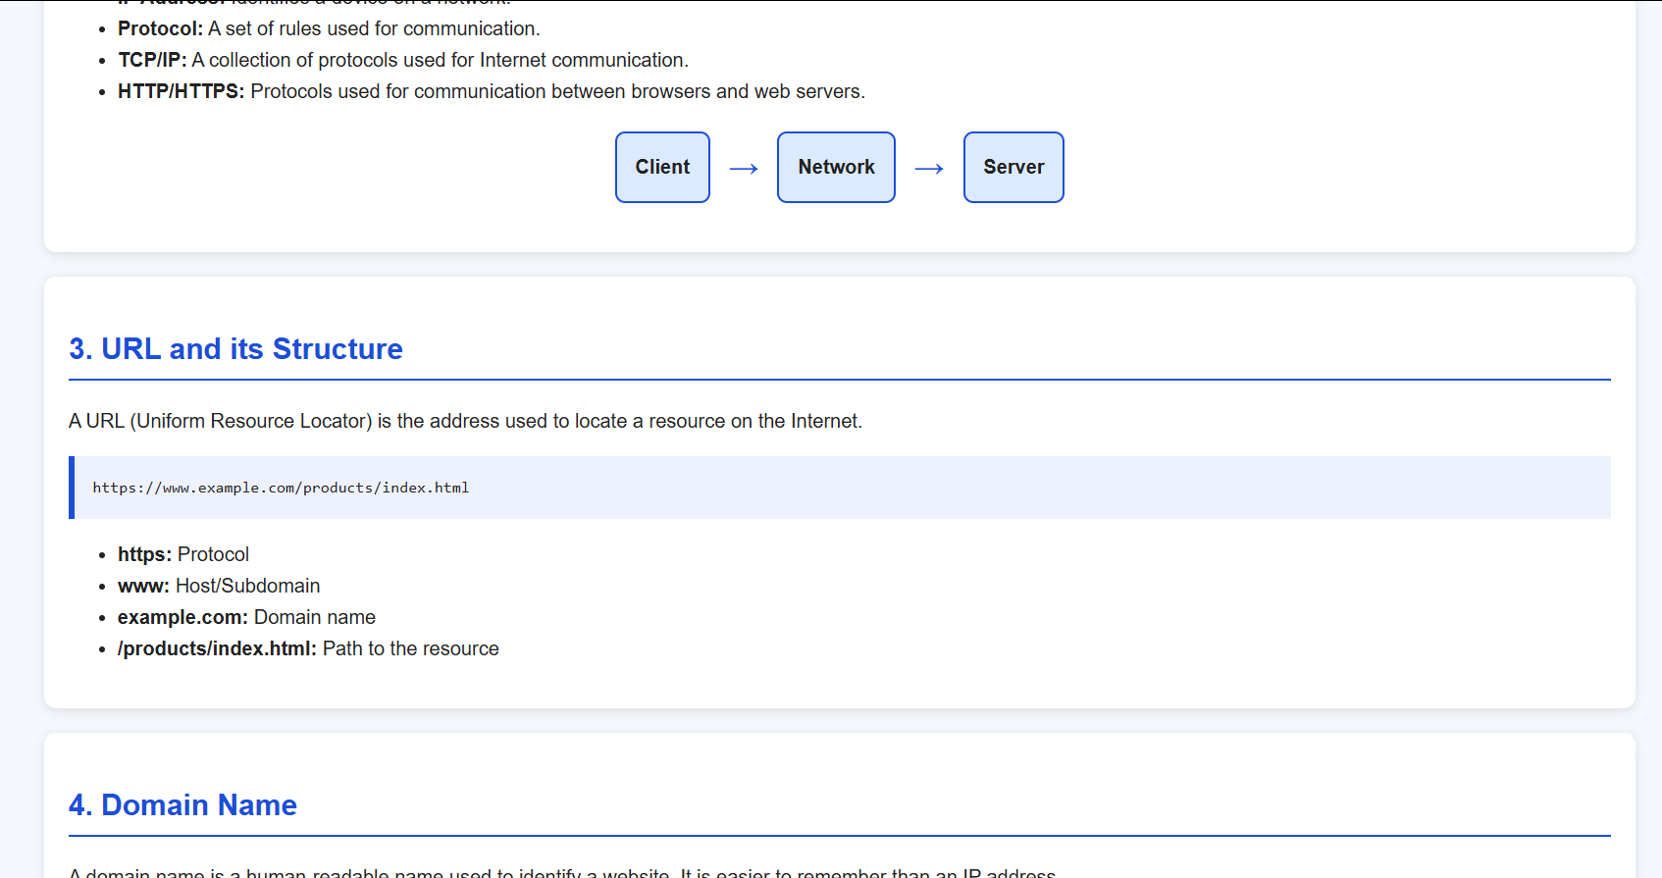
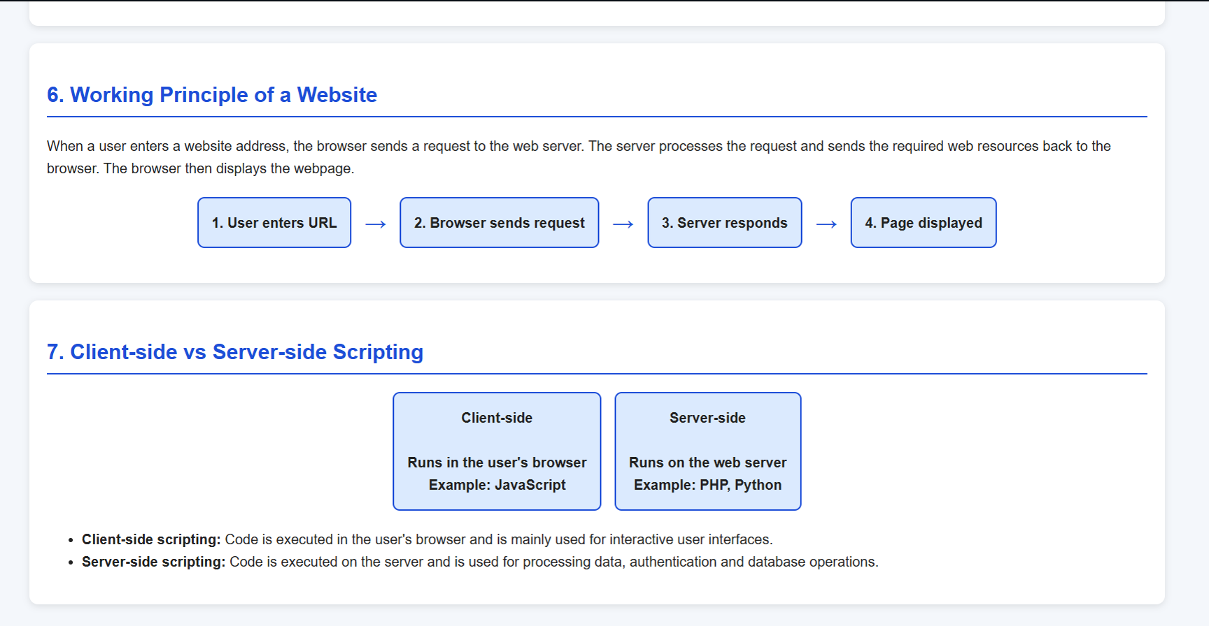

- Conclusion
This webpage provides a basic understanding of how the World Wide Web works. It explains the communication between clients and servers and the role of URLs, domains, browsers and web servers. The concepts are presented using simple diagrams for better understanding.

Scenario: A college wants to digitize its student admission process.
Task: Design a responsive Student Admission Form using HTML5 and CSS3.
Your webpage should demonstrate:
• HTML Form Elements
• Different Input Types
• Media Elements (Image/Video/Audio)
• CSS3 Selectors
• Box Model
• Responsive User Interface
ANSWER
1. HTML source code
<!DOCTYPE html>
<html>
<head>
<title>Student Admission Form</title>
<meta name="viewport" content="width=device-width, initial-scale=1.0">
<link rel="stylesheet" href="q2.css">
</head>

<body>

<div class="form">
<h1>Student Admission Form</h1>

<form>
<label>Full Name</label>
<input type="text" placeholder="Enter your name" required>

<label>Email</label>
<input type="email" placeholder="Enter email" required>

<label>Mobile Number</label>
<input type="tel" placeholder="Enter mobile number">

<label>Date of Birth</label>
<input type="date">

<label>Gender</label>
<input type="radio" name="gender"> Male
<input type="radio" name="gender"> Female
<input type="radio" name="gender"> Other

<label>Course</label>
<select>
<option>-- Select Course --</option>
<option>Computer Science</option>
<option>Electronics</option>
<option>Mechanical</option>
</select>

<label>12th Percentage</label>
<input type="number" min="0" max="100">

<label>Address</label>
<textarea rows="3" placeholder="Enter address"></textarea>

<label>Upload Photo</label>
<input type="file" accept="image/*">

<div class="media">
<h3>College Information</h3>

<img src="college.jpg" alt="College Campus">

<br><br>

<audio controls>
<source src="college-audio.mp3" type="audio/mpeg">
</audio>
</div>

<label>
<input type="checkbox" required>
I confirm that the information is correct.
</label>

<center>
<button type="submit">Submit</button>
<button type="reset">Reset</button>
</center>
</form>
</div>

</body>
</html>

- CSS

* {
box-sizing: border-box;
}

body {
font-family: Arial;
background: #eef2f7;
margin: 0;
padding: 20px;
}

.form {
max-width: 700px;
margin: auto;
background: white;
padding: 25px;
border: 2px solid #ddd;
border-radius: 10px;
}

h1 {
text-align: center;
color: #1d4ed8;
}

label {
display: block;
margin-top: 12px;
font-weight: bold;
}

input, select, textarea {
width: 100%;
padding: 9px;
margin-top: 5px;
border: 1px solid #aaa;
border-radius: 5px;
}

input[type="radio"],
input[type="checkbox"] {
width: auto;
}

.media {
text-align: center;
margin: 20px 0;
padding: 10px;
background: #f1f5f9;
}

img {
width: 150px;
height: 100px;
object-fit: cover;
}

button {
padding: 10px 20px;
margin: 10px 5px;
border: 0;
border-radius: 5px;
cursor: pointer;
}

button[type="submit"] {
background: #1d4ed8;
color: white;
}

@media (max-width: 600px) {
body {
padding: 8px;
}

.form {
padding: 15px;
}
}

- Explanation
The Student Admission Form is created using HTML5 form elements and CSS3 styling. Different input types are used to collect personal and academic information. CSS selectors, the box model and media queries are used to style the form and make it responsive. Image and audio elements are also included to demonstrate multimedia support.

- Output

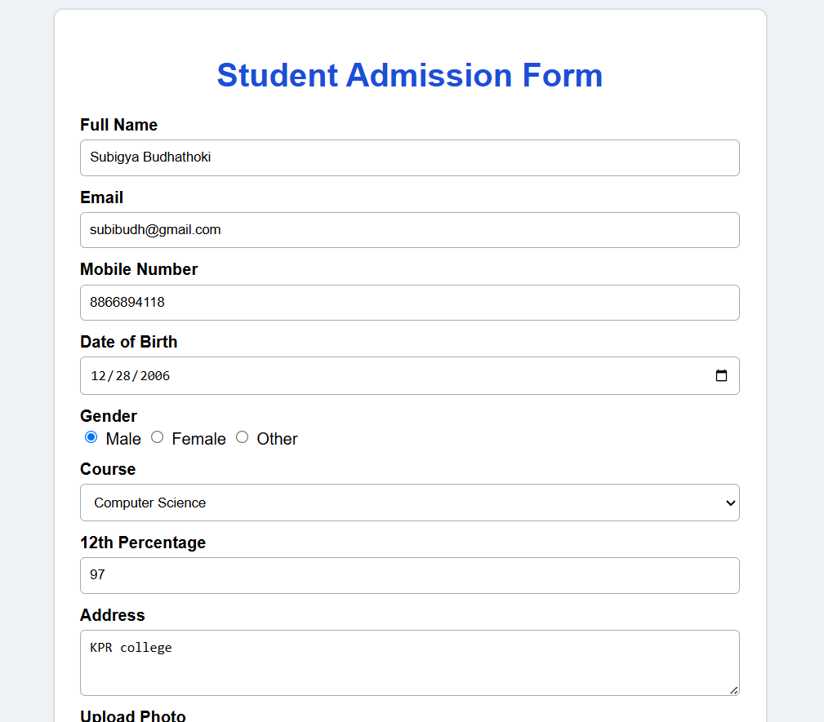
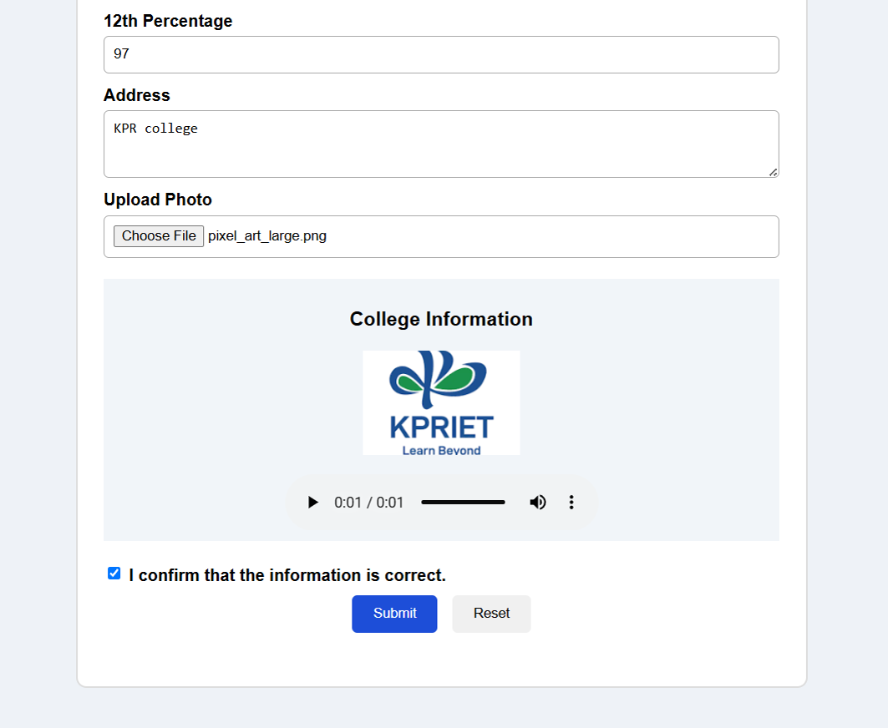

- Conclusion
The responsive admission form demonstrates the use of HTML5 and CSS3 for creating a structured and user-friendly webpage. It collects different types of student information and adapts to different screen sizes. HTML5 validation and multimedia elements make the form more useful and interactive.

Scenario: An online fashion store wants an attractive home page to improve customer engagement.
Task: Design the homepage using HTML5 and CSS3 by incorporating:
• Backgrounds and Borders
• Text Effects
• CSS Animations
• Multiple Column Layout
• User Interface Design Principles
ANSWER
- HTML source code
<!DOCTYPE html>
<html>
<head>
<title>StyleHub - Fashion Store</title>
<link rel="stylesheet" href="q3.css">
</head>
<body>

<header>
<h1>STYLEHUB</h1>
<p>Fashion for Every Style</p>
</header>

<nav>
<a href="#">Home</a>
<a href="#">Men</a>
<a href="#">Women</a>
<a href="#">Offers</a>
</nav>

<section class="hero">
<h2>New Fashion Collection</h2>
<p>Discover the latest styles at affordable prices.</p>
<div class="offer">FLAT 30% OFF</div>
</section>

<section class="products">

<div class="card">
<img src="shirt.jpg" alt="Shirt">
<h3>Casual Shirt</h3>
<p>Comfortable and stylish.</p>
<b>₹799</b><br><br>
<button>Shop Now</button>
</div>

<div class="card">
<img src="dress.jpg" alt="Dress">
<h3>Women's Dress</h3>
<p>Elegant and trendy.</p>
<b>₹999</b><br><br>
<button>Shop Now</button>
</div>

<div class="card">
<img src="shoes.jpg" alt="Shoes">
<h3>Sports Shoes</h3>
<p>Perfect for everyday use.</p>
<b>₹1299</b><br><br>
<button>Shop Now</button>
</div>

</section>

<footer>© 2026 StyleHub | All Rights Reserved</footer>

</body>
</html>
- CSS
* {
box-sizing: border-box;
}

body {
margin: 0;
font-family: Arial;
background: #f5f5f5;
}

header {
background: #111;
color: white;
text-align: center;
padding: 25px;
}

header h1 {
letter-spacing: 3px;
}

nav {
background: #333;
text-align: center;
padding: 12px;
}

nav a {
color: white;
text-decoration: none;
margin: 15px;
}

.hero {
text-align: center;
padding: 45px;
background: linear-gradient(120deg, #ddd, white);
border-bottom: 3px solid #111;
}

.hero h2 {
text-shadow: 2px 2px 4px #aaa;
text-transform: uppercase;
}

.offer {
display: inline-block;
background: #111;
color: white;
padding: 12px 25px;
border-radius: 20px;
animation: pulse 1.5s infinite;
}

@keyframes pulse {
50% { transform: scale(1.08); }
}

.products {
display: flex;
gap: 20px;
padding: 30px;
}

.card {
width: 33%;
background: white;
padding: 20px;
text-align: center;
border: 2px solid #ddd;
border-radius: 10px;
box-shadow: 0 3px 8px #ccc;
}

.card:hover {
transform: translateY(-5px);
transition: .3s;
}

.card img {
width: 100%;
height: 180px;
object-fit: cover;
border-radius: 8px;
}

button {
background: #111;
color: white;
padding: 10px 20px;
border: 0;
border-radius: 5px;
}

footer {
background: #111;
color: white;
text-align: center;
padding: 15px;
}

@media(max-width:650px) {
.products {
flex-direction: column;
}

.card {
width: 100%;
}
}

- Explanation
The webpage represents an online fashion store called StyleHub. HTML5 is used to create the header, navigation, hero section, product cards and footer. CSS3 provides backgrounds, borders, text effects, animations and a three-column product layout. Flexbox and media queries make the homepage responsive on smaller screens.

- Output
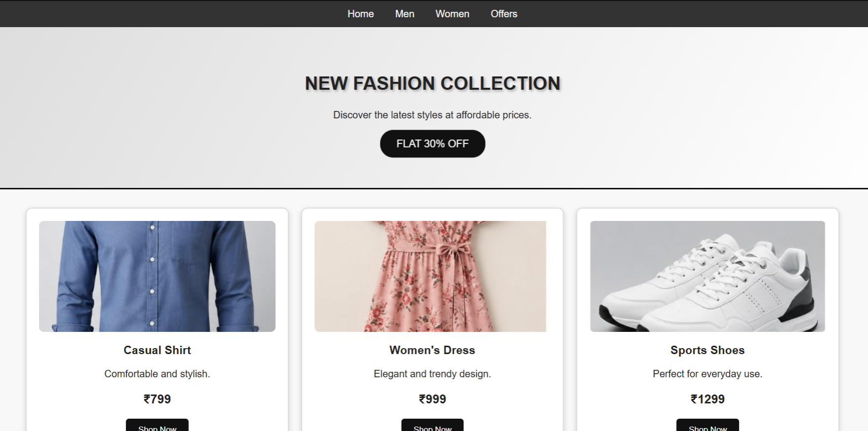

- Conclusion
The homepage demonstrates important HTML5 and CSS3 concepts required for an attractive web interface. CSS animations and text effects improve visual appeal, while the multiple-column layout organizes products clearly. The responsive design allows the webpage to work on both desktop and mobile screens.

Scenario: A school wants to automate the student grade calculation process.
Task: Develop a JavaScript program that accepts marks of five subjects and displays the Total, Average, Grade, and Pass/Fail status. The solution should demonstrate:
• Variables and Data Types
• Literals
• Operators
• Statements (Selection and Iteration)
• User-defined Functions
ANSWER
- HTML source code

<!DOCTYPE html>
<html>
<head>
<title>Grade Calculator</title>
<link rel="stylesheet" href="q4.css">
</head>
<body>

<div class="box">
<h1>Student Grade Calculator</h1>

<input type="number" id="m1" placeholder="Subject 1 Marks">
<input type="number" id="m2" placeholder="Subject 2 Marks">
<input type="number" id="m3" placeholder="Subject 3 Marks">
<input type="number" id="m4" placeholder="Subject 4 Marks">
<input type="number" id="m5" placeholder="Subject 5 Marks">

<button onclick="calculate()">Calculate</button>

<div id="result"></div>
</div>

<script src="q4.js"></script>
</body>
</html>

- CSS
body {
font-family: Arial;
background: #eef2f7;
text-align: center;
padding: 30px;
}

.box {
max-width: 500px;
margin: auto;
background: white;
padding: 25px;
border-radius: 10px;
box-shadow: 0 3px 10px #bbb;
}

input {
width: 80%;
padding: 9px;
margin: 6px;
}

button {
padding: 10px 25px;
background: #1d4ed8;
color: white;
border: 0;
border-radius: 5px;
}

#result {
margin-top: 20px;
line-height: 1.8;
}

- JavaScript
function calculate() {
let marks = [
Number(document.getElementById("m1").value),
Number(document.getElementById("m2").value),
Number(document.getElementById("m3").value),
Number(document.getElementById("m4").value),
Number(document.getElementById("m5").value)
];

let total = 0;

for (let mark of marks)
total += mark;

let average = total / 5;
let grade;

if (average >= 90)
grade = "A+";
else if (average >= 80)
grade = "A";
else if (average >= 70)
grade = "B";
else if (average >= 60)
grade = "C";
else if (average >= 50)
grade = "D";
else
grade = "F";

let status = marks.every(mark => mark >= 40) ? "PASS" : "FAIL";

document.getElementById("result").innerHTML =
"Total: " + total +
"<br>Average: " + average.toFixed(2) +
"<br>Grade: " + grade +
"<br>Status: " + status;
}

- Explanation
The program accepts marks for five subjects using HTML input fields. JavaScript stores the marks in an array, calculates the total and average using operators and a loop, and determines the grade using conditional statements. The calculate() function is a user-defined function that performs the complete calculation.

- Output

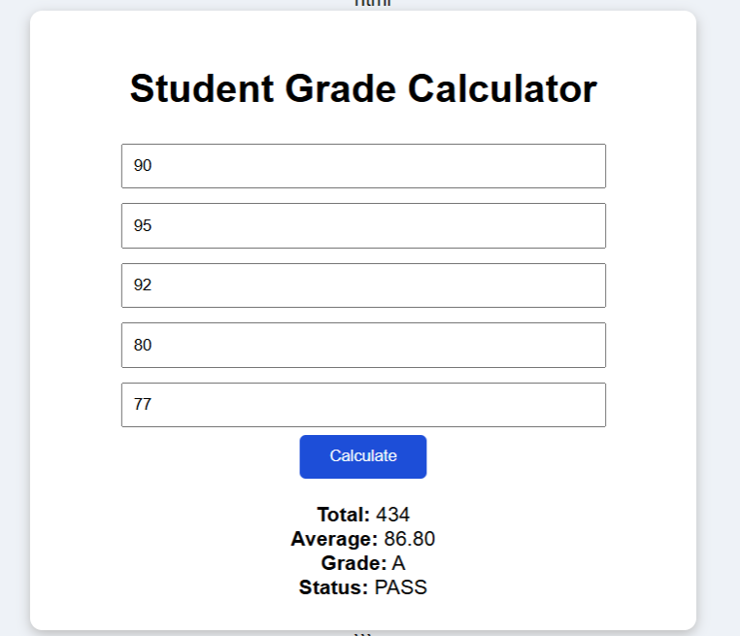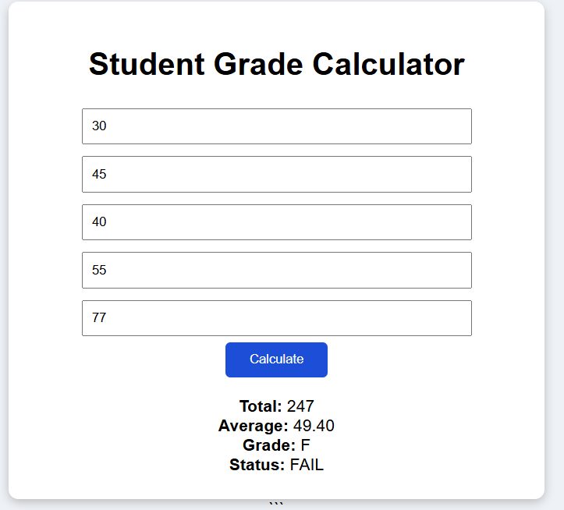
Status: PASS example Status: FAIL example

- Conclusion
The program demonstrates the use of JavaScript variables, operators, functions, selection and iteration statements. It successfully calculates the student's total, average, grade and pass/fail status based on the entered marks.

Scenario: A supermarket wants to generate customer bills automatically.
Task: Develop a JavaScript program to calculate the bill amount for three purchased products.
The program should:
• Accept quantity and unit price for each product
• Calculate the total bill
• Apply a 10% discount if the total amount exceeds ₹2000
• Display the final payable amount
The solution should demonstrate:
• Variables and Data Types
• Literals
• Operators
• Statements
• User-defined Functions
ANSWER
- HTML source code

<!DOCTYPE html>
<html>
<head>
<title>Supermarket Bill</title>
<link rel="stylesheet" href="q5.css">
</head>
<body>

<div class="box">
<h1>Supermarket Bill</h1>

<p>Product 1</p>
<input type="number" id="q1" placeholder="Quantity">
<input type="number" id="p1" placeholder="Unit Price">

<p>Product 2</p>
<input type="number" id="q2" placeholder="Quantity">
<input type="number" id="p2" placeholder="Unit Price">

<p>Product 3</p>
<input type="number" id="q3" placeholder="Quantity">
<input type="number" id="p3" placeholder="Unit Price">

<br>
<button onclick="calculateBill()">Generate Bill</button>

<div id="result"></div>
</div>

<script src="q5.js"></script>
</body>
</html>

- CSS
body {
font-family: Arial;
background: #eef2f7;
text-align: center;
padding: 30px;
}

.box {
max-width: 550px;
margin: auto;
background: white;
padding: 25px;
border-radius: 10px;
box-shadow: 0 3px 10px #bbb;
}

input {
width: 40%;
padding: 9px;
margin: 6px;
}

button {
padding: 10px 25px;
background: #1d4ed8;
color: white;
border: 0;
border-radius: 5px;
}

#result {
margin-top: 20px;
line-height: 1.8;
}

- JavaScript

function calculateBill() {
let q1 = Number(document.getElementById("q1").value);
let p1 = Number(document.getElementById("p1").value);

let q2 = Number(document.getElementById("q2").value);
let p2 = Number(document.getElementById("p2").value);

let q3 = Number(document.getElementById("q3").value);
let p3 = Number(document.getElementById("p3").value);

let total = (q1 * p1) + (q2 * p2) + (q3 * p3);
let discount = 0;

if (total > 2000)
discount = total * 0.10;

let payable = total - discount;

document.getElementById("result").innerHTML =
"Total: ₹" + total.toFixed(2) +
"<br>Discount: ₹" + discount.toFixed(2) +
"<br>Final Payable: ₹" + payable.toFixed(2);
}
- Explanation
The program accepts the quantity and unit price of three products and calculates the total bill. If the total exceeds ₹2000, a 10% discount is applied. A user-defined JavaScript function performs the calculations and displays the total, discount and final payable amount.

- Output
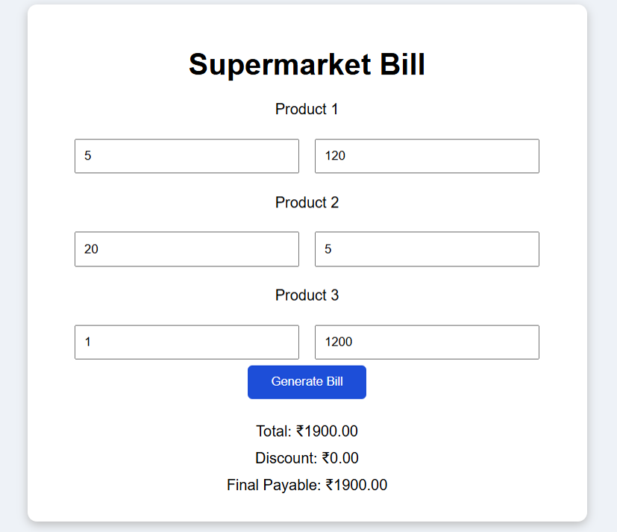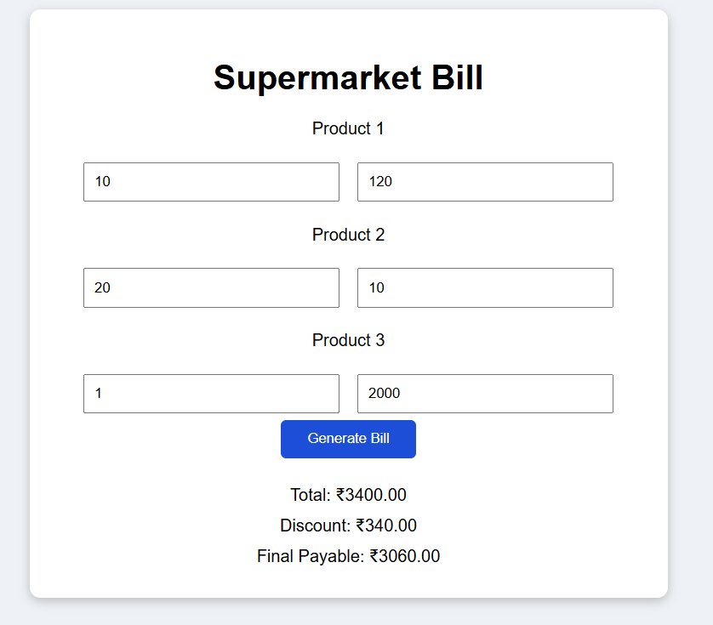
Bill exceeding rs 2000 (no discount) Bill not exceeding rs 2000 (10% discount)

- Conclusion
The program demonstrates JavaScript variables, literals, operators, conditional statements and user-defined functions. It successfully automates the supermarket billing process and applies the required discount based on the total bill.

